**Problem (a)**

1. Analyze the source code structure and draw a high-level block diagram of the function hierarchy and their communication dependencies (critical variables). **Submit the block diagram of the software architecture of the reference code as part of your lab report.** Note: in addition to the edge detection, the original source doe also supports image corner detection and smoothing. You can ignore functions that are not used in the edge detection code.

Block diagram attached at the end of this report (Reference 1).

1. Modify the source code to be static and synthesizable. Modify the sources for a fixed input image sensor size of 76x95 pixels. Remove any unnecessary communication/dependencies. At the end, put each function called inside the main() function in a separate header/source file in order to make the example easier. **Report on the code changes that you performed.**
2. Critical variables were identified to be the following:

in, mid, bpArray, r, x_size, y_size, bt, drawing_mode, max_no_corners, max_no_edges, mode

1. Modified block diagram attached at the end of the report (Reference 2).
2. The functions that are only relevant to edge detection were remained. Also, the parameters in pointer form were changed to be static.

The followings are the changes made:

1. in, mid, r were given arrays with specific sizes. (r was originally dynamically assigned by malloc.)
2. x_size and y_size were held constant
3. switch block was removed and replaced with case 1 (which corresponds to the edge detection)
4. Make sure that parameters passed between functions are not of pointer type.

Actual arrays and constant values were used as parameters instead of pointers.

**Problem (b)**

1 & 2 & 3) Introduce a single behavior of appropriate name in each file. Let the behavior encapsulate all local variables and functions. Replace parameters with equivalent behavior ports for external communication. Make sure that parameters passed between functions are not of pointer type.

The following files were created:

1. detect_edges.sc
2. edge_draw.sc
3. get_image.sc
4. get_int_sc
5. get_int_bu.sc
6. main.sc
7. monitor.sc
8. put_image.sc
9. setupbrightness.sc
10. stimulus.sc
11. susan.sc
12. susan_thin.sc
13. susanedges.sc

**[Reference 1]Block diagram of the original version of susan.c**

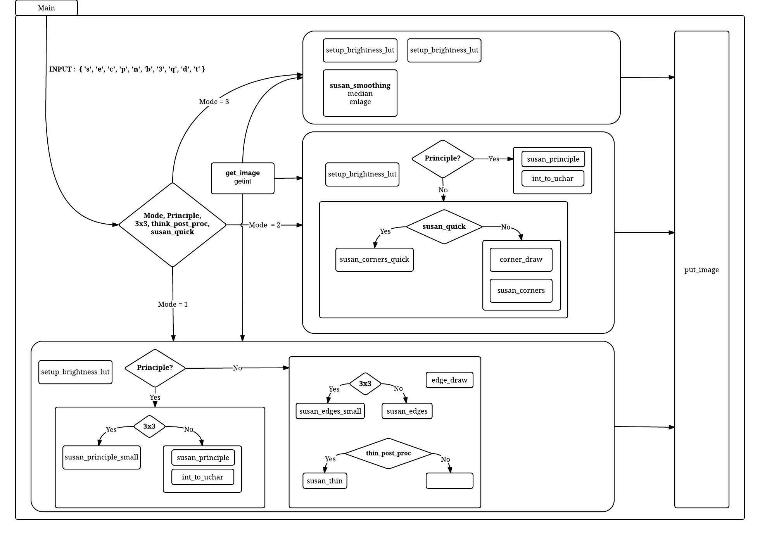

**[Reference 2]Block diagram of the simplified version of susan.c**

